Reference websites :
https://www.scabalindia.com/html/index.html SCABAL
https://www.calcinedbauxiteindia.com/ Dynamic Exim Corporation
https://www.qingjiangminerals.com/ Henan Qingjiang industrial co ltd.

Calcined Bauxite
1. Calcined Bauxite Kya Hai?
Ye raw bauxite ore ka ek refined roop hai. Jab raw bauxite ko
tak garam kiya jata hai, toh usme se saara moisture paani aur impurities nikal jaati hain. Is process ko calcination kehte hain. Iske baad jo bachta hai, wo bahut he sakht (hard) aur heat-resistant material hota hai.

2. Ye Kaise Banta Hai?
Sabse pehle khadaon mines se nikle raw bauxite ko machine se chota-chota toda jata hai.
In tukdon ko Rotary Kiln ya Shaft Kiln badi bhatthi mai dala jata hai.
Ise bahut high temperature lagbhag
par garam kiya jata hai. Isse bauxite ke andar ke water molecules khatam ho jate hain.
Garam hone ke baad ise thanda kiya jata hai aur zaroorat ke hisaab se powder ya chhote daano grains mai peesa jata
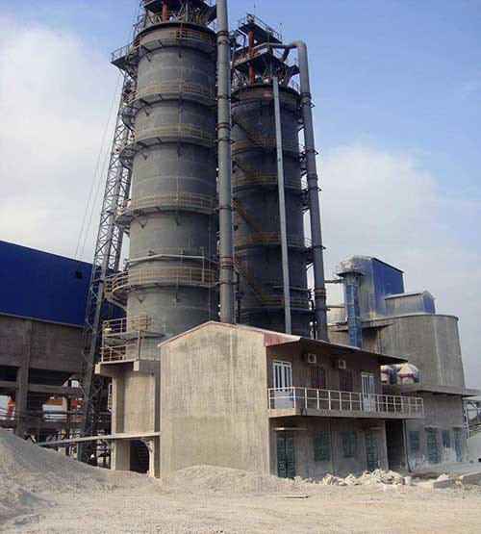

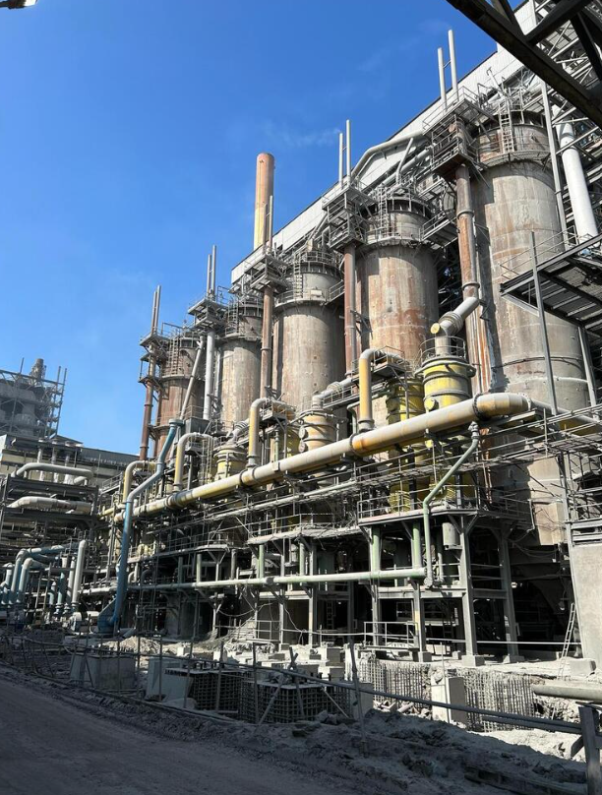
Shaft Kiln picture
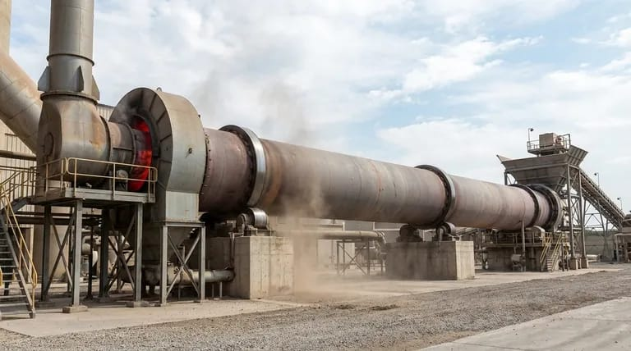
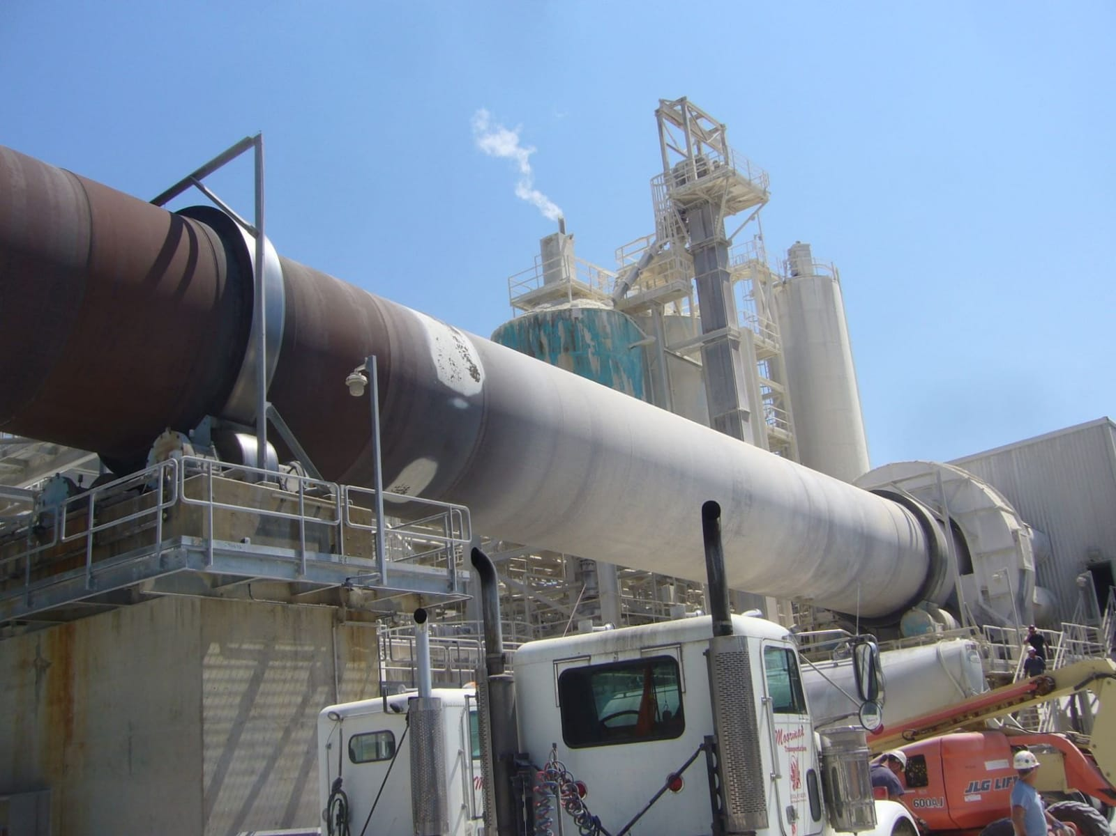
Rotary Kiln picture

3. Iska Colour Kya Hota Hai?
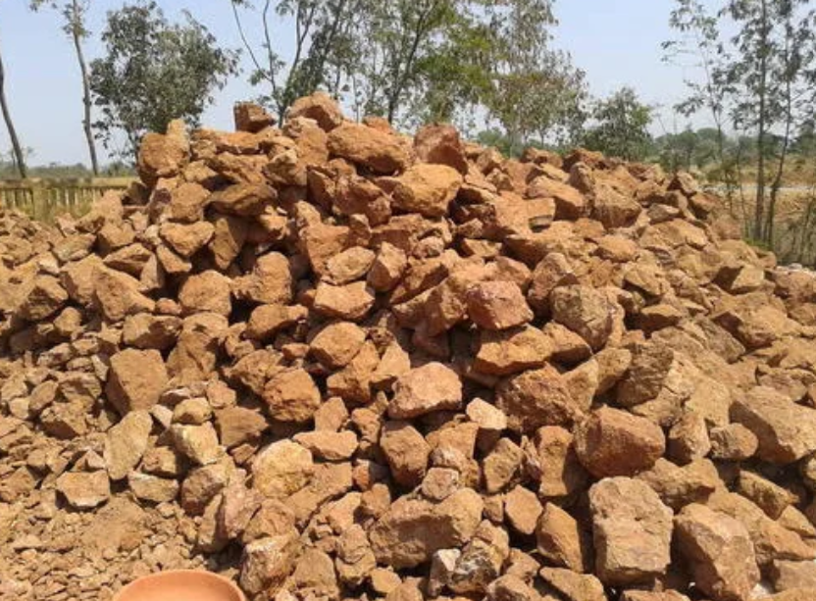
Brown colour Raw bauxite.
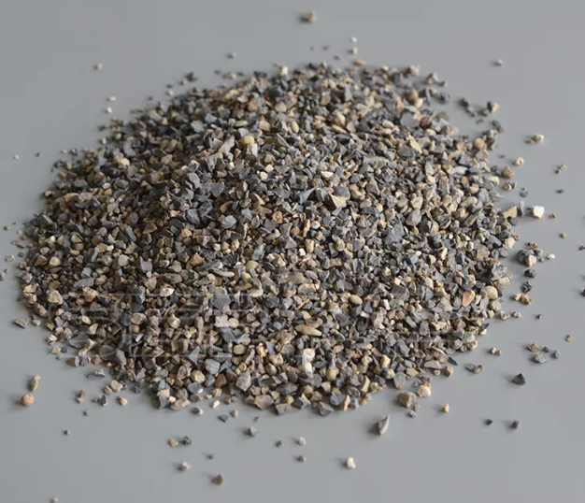
Grey colour Calcined Bauxite
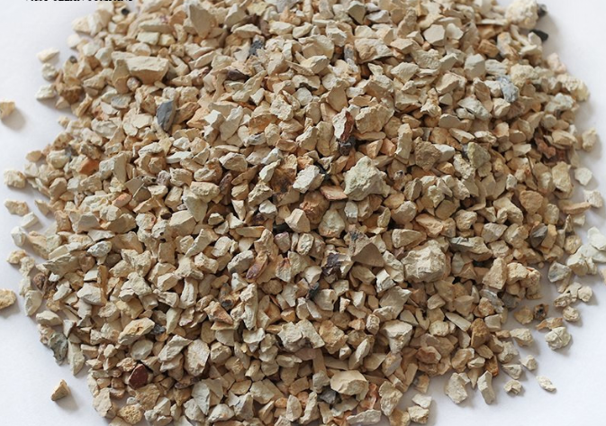
Light Brown Calcined Bauxite colour

Calcined bauxite ka rang uski quality aur impurities par depend karta hai:
Ye Light Grey to Brown ya Off-White rang ka hota hai.
Jitna zyada alumina hoga, utna he ye safed ya halka grey dikhega.
Agar iron zyada ho, toh ye Reddish-Brown ya Dark Grey/Black bhi ho sakta hai.

4. India Mai Kaunsa Milta Hai Aur Purity Kya Hoti Hai?
India mai calcined bauxite ke bade centers Gujarat (Jamnagar) aur Chhattisgarh mai hain.

Purity (Alumina Content): India mai milne wale calcined bauxite mai Alumina ki matra aam taur par 60 se 88 % tak hote hai.
Refractory Grade: 80- 88% hota hai
Abrasive Grade:75 to 80%
Cement Grade 40 SE 50 %

5. Iska Use Kahan-Kahan Hota Hai?

cement chemicals ,industry ,welding industries, steel industries, glass industries, Chemicals, Abrasives, Refractories ,road construction.

6. Iske Andar Kya-Kya Hota Hai?
Alumina ,Silica ,Iron Oxide, Titanium Dioxide

7 .mesh size

Application Common Size (mm) Common Size (Mesh)
Furnace Bricks 1–3 mm, 3–5 mm 8–30 Mesh
Road Safety 1–3 mm 6/16 Mesh
Abrasive/Polishing < 1 mm 100, 200, 325 Mesh
Cement/Chemical Fines (< 2 mm) -200 Mesh

8. Ye thoda Brownish ya Dark Grey rang ka hota hai.

china india

Alumina 85 to 90 % high purity 75 to 85 % medium purity
Iron 1.5 to 2.5 low 2.to 5 % higher
Bulk Density 3.2 to 3.4 high 2.8 to 3.1 medium
price higher price lower and cheap price
best use High-end Refractories Road Surfacing, Abrasives, Cement

9. Calcined bauxite Cement Grade.
- High-Alumina Cement Banana: Calcined bauxite ka upyog mukhya roop se High-Alumina Cement banana ke liye kiya jata hai. Is tarah ka cement tab banaya jata hai jab bauxite aur limestone ko ek saath mix kiya jata hai.
- Mazbooti aur Durability: Ye cement ki strength (mazbooti) badhata hai aur clinker ki quality ko bhi behtar karta hai.
- Heat aur Wear Resistance: Cement jisme calcined bauxite hota hai, usmein garmi aur ghisawat (abrasion) se ladne ki taqat zyada hoti hai. Is wajah se ise industrial floors, roads aur runways jaisi jagahon par use kiya jata hai jahan heavy traffic hota hai.
- Kiln Lining mein Istemal: Calcined bauxite ka upyog refractory materials (jaise bricks aur castables) banana mein hota hai jo cement plant ki kilns aur furnaces ke andar ki lining ke liye zaroori hote hain, kyunki ye 1600°C se upar ka temperature jhel sakta hai.
- Cement Substitute: Kuch cases mein calcined bauxite residue ko ordinary cement ki jagah partial replacement (lagbhag 10%) ke roop mein bhi use kiya ja raha hai taaki construction ko aur sustainable banaya ja sake.
- 1. High-Alumina Cement (HAC) Banane ke liye
- Iska sabse bada upyog High-Alumina Cement banane mein hota hai.
- Kaise milate hain?: Selected quality ke calcined bauxite ko limestone (chuna pathar) ke saath ek khaas ratio mein mix kiya jata hai. Inhe bahut high temperature par garm karke pisa jata hai.
- Kya banta hai?: Isse jo cement banta hai, wo ordinary cement se bahut alag hota hai. Ye sirf 2 se 4 ghante mein set hona shuru ho jata hai aur 24 ghante mein poori mazbooti pakad leta hai.
- Kahan use hota hai?: Iska istemal samundar ke paas ke construction (salt water resistance ke liye), chemical plants, aur aise tunnels mein hota hai jahan acid ya sulphate ka khatra ho.
- 2. High-Strength Concrete mein 'Aggregate' ki tarah
- Calcined bauxite ko cement ke saath concrete banate waqt aggregate (rodi ya mitti ki jagah) ki tarah bhi milaya jata hai.
- Kaise milate hain?: Iske 0-1 mm ya 1-3 mm size ke daano (grains) ko mortar ya concrete mix mein milaya jata hai.
- Kya banta hai?: Isse Refractory Concrete ya Ultra-High Performance Concrete (UHPC) banta hai jo sadharan concrete se kahin zyada sakht (hardness 8-9 Mohs) hota hai.
- Kahan use hota hai?:
  - Anti-Skid Roads: Sadak ke un modon par jahan accident ka khatra zyada ho, ise cement aur resin ke saath upar se bichhaya jata hai taaki gaadiyan phisle nahi.
  - Industrial Flooring: Aisi factory floors jahan heavy machines chalti hain aur ghisawat zyada hoti hai.
- 3. Refractory Bricks aur Lining ke liye
- Agar aap cement plant chala rahe hain, toh ye cement ke andar milane ke bajaye cement ki bhatti (kiln) ke liye zaroori hai.
- Kya banta hai?: Isse Refractory Bricks aur Castables bante hain.
- Kahan use hota hai?: Cement ki bhatti ke andar ki deewarein banane mein, kyunki ye 1600°C se upar ki garmi jhel leta hai aur bhatti ko pighalne se bachata hai.
1. Iron aur Steel Industry
Steel plants mein calcined bauxite ka sabse zyada upyog furnaces aur ladles ki lining ke liye kiya jata hai.
Kahan supply hota hai: India jaise bade plants mein refractory bricks aur castables ke roop mein supply hota hai.
- Kaise use hota hai: Isse bani bricks furnace ke andar ke pighle hue lohe (molten metal) ki garmi ko jhelne ke liye deewaron par lagayi jati hain
2. Cement Industry
Cement banane ki process mein Rotary Kiln ka temperature 1500°C se upar chala jata hai, wahan iska use zaroori hai.
- Kahan supply hota hai: India ke cement giants iska upyog kiln lining ke liye karte hain.
- Kaise use hota hai: Kilns, preheaters aur clinker coolers ke andar ki protection layer banane mein.
3. Aluminium aur Glass Industry
- Aluminium: India ke bade plants mein alumina refineries aur smelters ki lining mein refractory bauxite use hota hai.
- Glass: Glass ki bhattiyon (furnaces) mein jahan kaanch pighlaya jata hai, wahan ki walls refractory bauxite bricks se bani hoti hain taaki corrosion na ho
4. Refractory Material Manufacturers
Bahut se calcined bauxite suppliers seedha un companies ko supply karte hain jo aage chal kar bricks aur castables banati hain.
- Pramukh Suppliers India bade players in bauxite manufacturers se raw material kharidte hain.
Why Buyers from China Choose Calcined Bauxite from India
China ke buyers India se calcined bauxite isliye kharidenge kyunki India ka calcined bauxite high quality ka hota hai, price competitive hota hai, supply reliable hoti hai aur material ka standard international level ka hota hai or humare flexible payment terms hote hai.
1. Domestic Supply ki Kami (Environmental Shutdowns)
China ne haal ke saalon mein apne kai bauxite mines aur calcination plants ko band kar diya hai kyunki wo bahut zyada pollution faila rahe the (jaise Shanxi aur Guizhou provinces mein

Example: Jab China ki apni mines band hoti hain, toh unki steel factories ko refractory bricks banane ke liye raw material ki zaroorat hoti hai. Is gap ko bharne ke liye wo India jaise bade bauxite resources wale desh se maal mangwate hain
2. Sasta aur Reliable Transport (Ocean Freight)
India ki bhaugolik sthiti (geographical location) aisi hai ki samudri raste se China tak maal bhejna sasta padta hai

Example: Guinea jaise dur ke deshon se bauxite mangwane ke muqable, Gujarat (India) ke ports se China ke ports tak freight charges kam hote hain, jo RKCB ko unke liye economical banata hai
3. Gibbsite Bauxite (Asaan Processing)
Indian bauxite, khaas taur par jo Gujarat se aata hai, wo Gibbsite type ka hota hai.
Example: Gibbsite bauxite ko process karna China ki kai alumina refineries ke liye asaan aur kam kharchila hota hai. Ye unke machines aur furnace ke design ke hisaab se fit baithta hai.
4. Supply ki Suraksha (Import Diversification)
China sirf ek desh (jaise Guinea ya Australia) par poori tarah nirbhar nahi rehna chahta.

Example: Agar kisi aur desh mein war ya supply chain ruk jati hai, toh India unke liye ek back-up/secondary source ki tarah kaam karta hai taaki unka industrial kaam na ruke
Hum China se import isliye karte hai kyunki :
- Supply hamesha continuous rahe, kabhi shortage na ho.
- Market ke liye best quality aur competitive price available ho.
- Humare customers ko consistent aur reliable material mile.
- Different grades aur specifications ke liye options available rahe.
Is tarah se hum ensure karte hai ki humari company ka calcined bauxite ka business smooth chal raha ho aur hum apne buyers ko best service aur material de paaye
Calcined bauxite in country ke pass milta hai:
India
China
Guyana
Brazil
Austrilia
Jamaica
Indonesia
Guinea
(calcined bauxite (refractory grade) mainly China, India, Guyana, Brazil) milta hai .

• China –

Al₂O₃: 85–90%
SiO₂: 4–8%
Fe₂O₃: 1.5–2.5%
sabse bada supplier hai,
processing aur calcination strong hai,
different grades easily mil jate hai,
lekin kabhi kabhi quality fluctuate hoti hai.

• India –
Al₂O₃: 85–88%
SiO₂: 5–9%
Fe₂O₃: 1.5–2.5%
consistent quality milti hai,
refractory grade ke liye accha hai,
price competitive hota hai,
supply reliable hoti hai.

• Guyana –
Al₂O₃: 88–92%
SiO₂: 2–5%
Fe₂O₃: 1–2%
best quality bauxite mana jata hai,
high alumina aur low impurities,
refractory ke liye top grade material.

• Brazil –
Al₂O₃: 84–88%
SiO₂: 4–8%
Fe₂O₃: 1.5–2.5%
large reserves + stable quality,
industrial use ke liye accha material,
export reliable hai.

• Australia –
Al₂O₃: 80–85%
SiO₂: 5–10%
Fe₂O₃: 2–3%
bahut bada raw bauxite producer,
lekin jyada tar aluminium industry me use hota hai,
calcined refractory me kam use hota hai.

• Guinea –
world ka sabse bada reserve,
raw material strong hai,
lekin processing (calcination) itni developed nahi hai.

• Indonesia –
raw bauxite milta hai,
lekin export rules change hote rehte hai,
isliye supply stable nahi hoti.
• Jamaica –
purana aur trusted source,
mainly aluminium industry ke liye,
refractory use limited hai.

Quick Comparison Table: China vs India Calcined Bauxite
Feature | China Calcined Bauxite | India Calcined Bauxite
Alumina (Al₂O₃) | High Purity | Medium Purity
Iron (Fe₂O₃) | Low | Higher
Bulk Density | High | Medium
Price | Expensive | Economical / Cost-effective
Best Use | High-end Refractories | Road Surfacing, Abrasives, Cement

1. China Calcined Bauxite Specifications (RKB Grades)
Technical Data Sheet (TDS) – Calcined Bauxite
Parameter | RKB90 | RKB88 | RKB87 | RKB85 | RKB80 | RKB75
Al₂O₃ (%) | ≥ 90.0 | ≥ 88.0 | ≥ 87.0 | ≥ 85.0 | ≥ 80.0 | ≥ 75.0
SiO₂ (%) | ≤ 3.5 | ≤ 5.5 | ≤ 7.0 | ≤ 8.0 | ≤ 10.0 | ≤ 16.0
Fe₂O₃ (%) | ≤ 1.5 | ≤ 1.6 | ≤ 1.8 | ≤ 2.0 | ≤ 2.0 | ≤ 2.0
TiO₂ (%) | ≤ 3.8 | ≤ 4.0 | ≤ 4.0 | ≤ 4.0 | ≤ 4.0 | ≤ 4.0
CaO + MgO (%) | ≤ 0.35 | ≤ 0.40 | ≤ 0.40 | ≤ 0.40 | ≤ 0.50 | ≤ 0.50
K₂O + Na₂O (%) | ≤ 0.35 | ≤ 0.40 | ≤ 0.40 | ≤ 0.40 | ≤ 0.50 | ≤ 0.50
Bulk Density (g/cc) | ≥ 3.35 | ≥ 3.25 | ≥ 3.20 | ≥ 3.10 | ≥ 2.90 | ≥ 2.80
Moisture (%) | ≤ 0.3 | ≤ 0.3 | ≤ 0.3 | ≤ 0.3 | ≤ 0.5 | ≤ 0.5

2. India Calcined Bauxite Typical Specifications
Technical Data Sheet (TDS) – Calcined Bauxite (India)
Parameter | High Purity Grade | Medium Purity Grade | Low Grade
Al₂O₃ (%) | 88 – 90% | 80 – 87% | 75 – 79%
SiO₂ (%) | 3 – 6% | 6 – 10% | 10 – 16%
Fe₂O₃ (%) | 1.5 – 2.0% | 2.0 – 2.5% | 2.0 – 3.0%
TiO₂ (%) | 3.5 – 4.0% | 3.0 – 4.0% | 3.0 – 4.0%
CaO + MgO (%) | 0.3 – 0.5% | 0.4 – 0.6% | 0.5 – 0.7%
K₂O + Na₂O (%) | 0.3 – 0.5% | 0.4 – 0.5% | 0.4 – 0.6%
Bulk Density (g/cc) | 2.8 – 3.2 | 2.6 – 3.0 | 2.5 – 2.8

